VPC Task-01
1. Create VPC with 2 private and 2 public subnets.

Open the VPC Console in AWS
- Sign in to the AWS Management Console search for VPC and open VPC Dashboard..
- Create VPC.

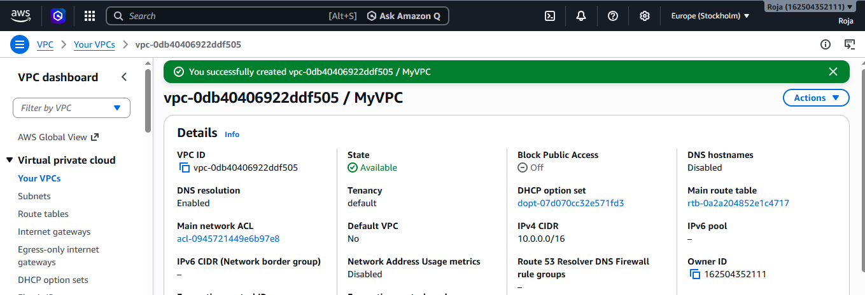

- Create an Internet Gateway and attached VPC
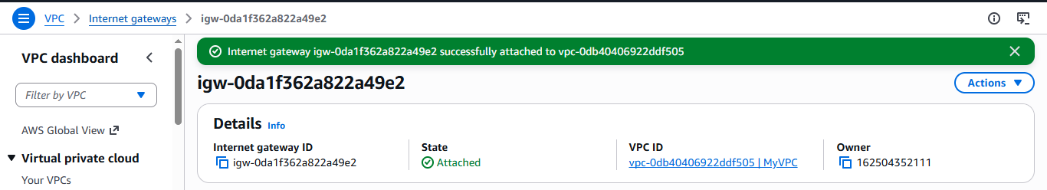
- Create Two Private Subnets and below is the Private subnet 1:
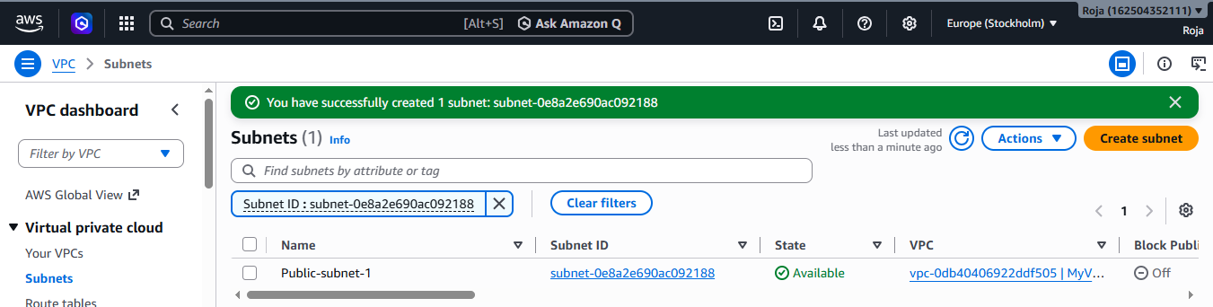

- Create a Private subnet 2:
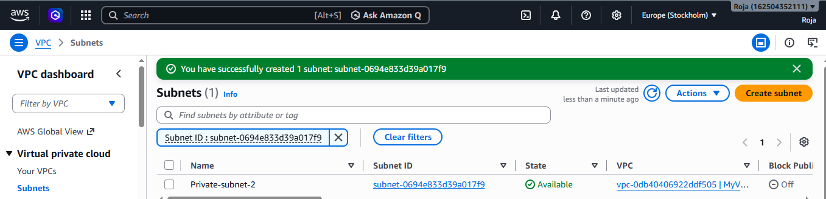
- Create Two Public Subnets and below is the Public subnet 1:
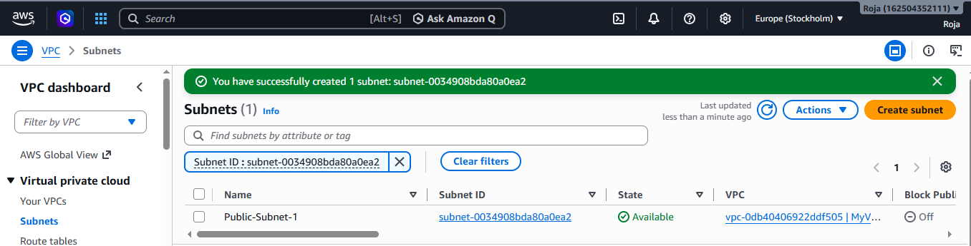
- Create Public Subnet 2:
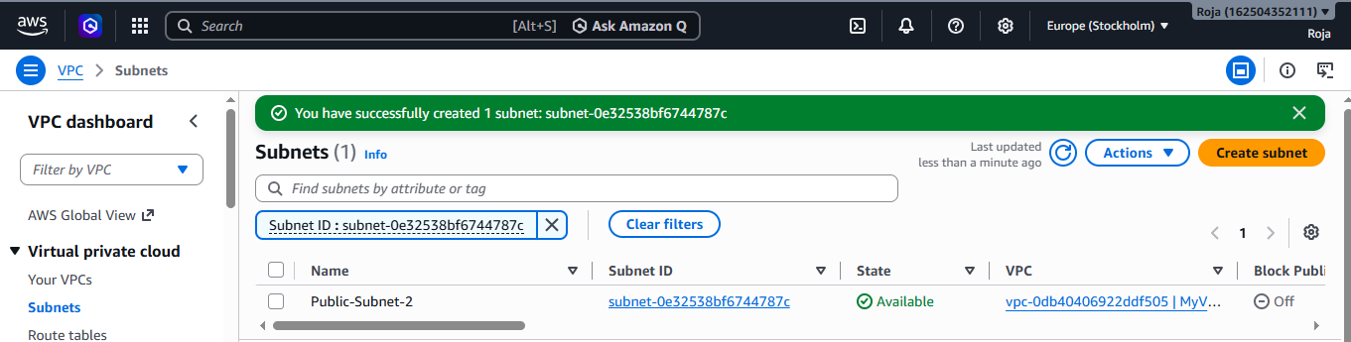

2. Enable DNS Hostname in VPC
Open VPC dashboard, in the left navigation pane, click Your VPCs and select VPC to enable DNS Hostname.
Click Actions. Select Edit VPC settings and Enable DNS resolution and Enable DNS hostname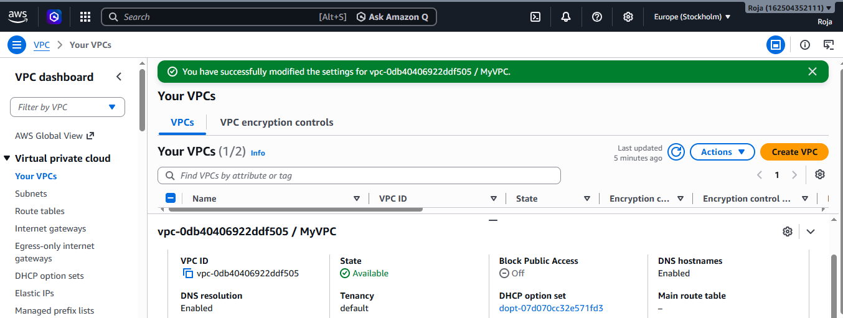
3. Enable Auto Assign Public IP in 2 public subnets.

- Open VPC dashboard, in the left navigation pane, click Subnets and select the Public Subnet 1.
- Click Actions. Select Edit Subnet settings, under auto assign IP settings enable auto-assign public IPv4 address and save.

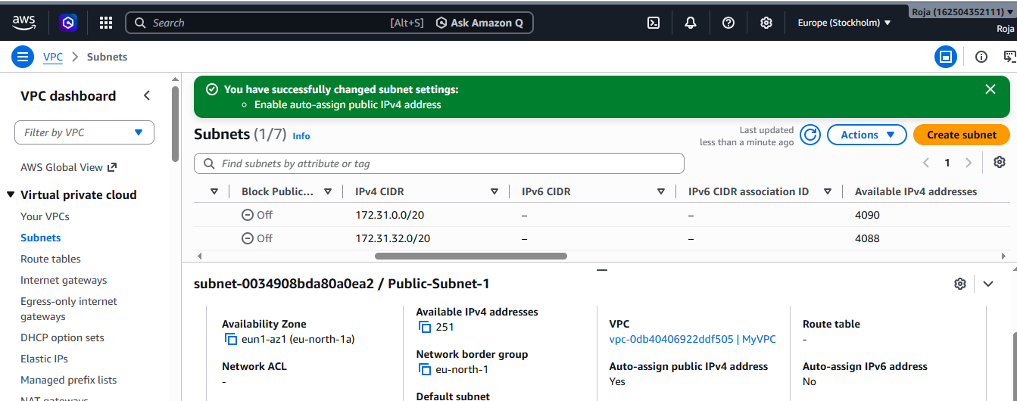

- In the left navigation pane, click Subnets and select the Public Subnet 2.
- Click Actions. Select Edit Subnet settings, under auto assign IP settings enable auto-assign public IPv4 address and save.

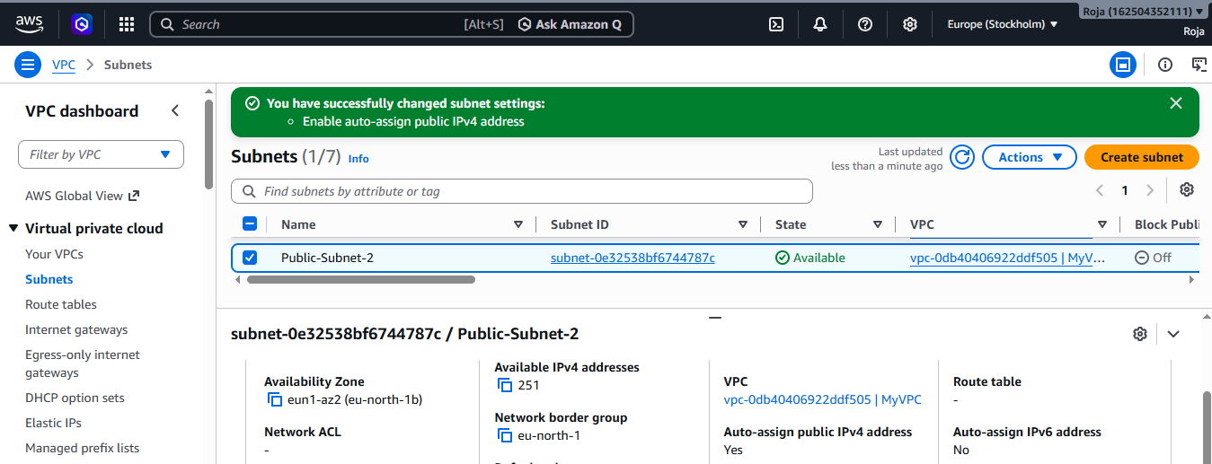

4. Add 2 private subnets in private route table.
- Go to AWS Console → VPC.
- In the left menu, click Route Tables.
- Click Create route table.
- Enter a Name tag as Private route table, select VPC and click on create route table.

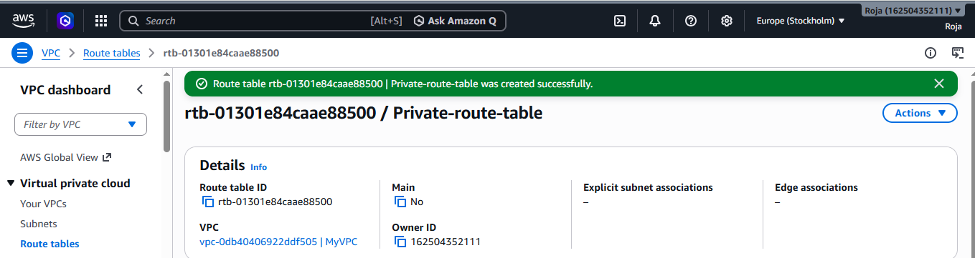
- In the left navigation pane, click Route Tables.
- Select your private route table.
- Select the Subnet Associations tab and select Private subnet 1.
- Click Edit subnet associations and click save associations.
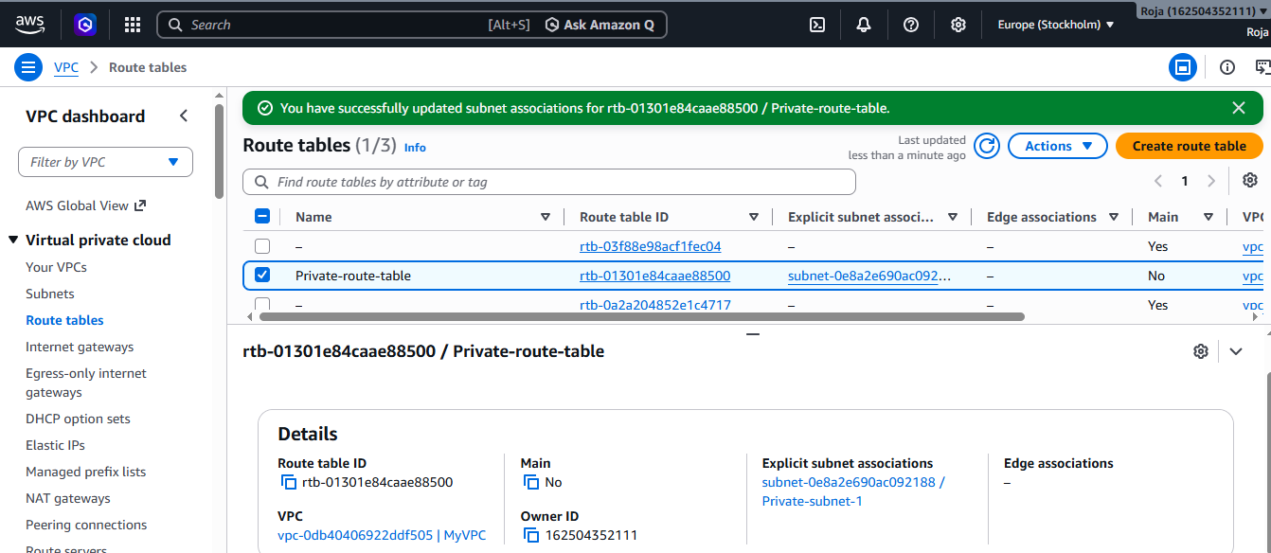
- Stay in the Subnet Associations tab. Click Edit subnet associations again.
- Now select Private Subnet 2 and click save association.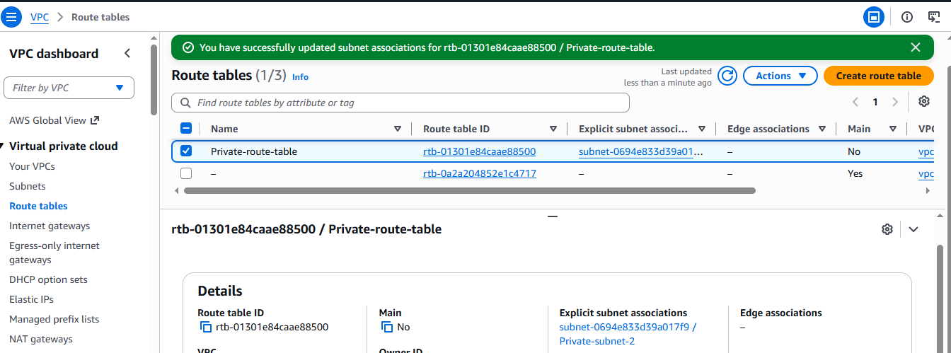
5. Add 2 public subnets in public route table.
- In the left navigation pane, click Route Tables.
- Select your public route table.
- Select the Subnet Associations tab and select Public subnet 1.
- Click Edit subnet associations and click save associations.
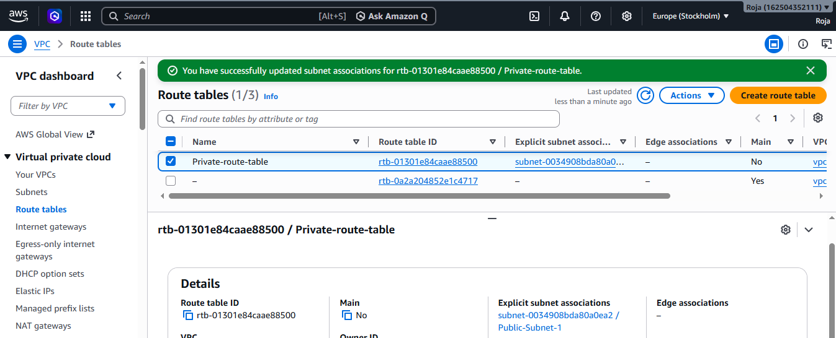

- Stay in the Subnet Associations tab. Click Edit subnet associations again.
- Now select Public Subnet 2 and click save association.
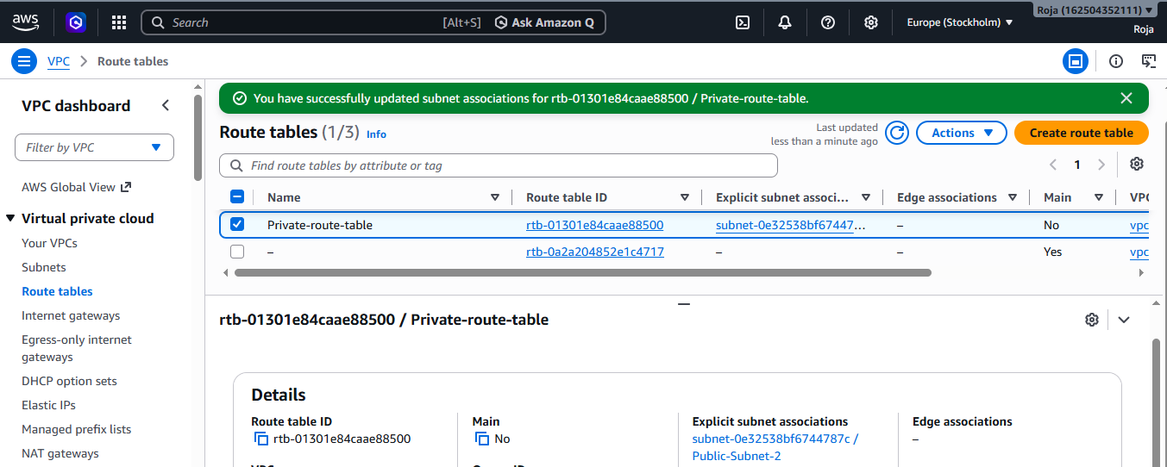

6. Public route table will have the routes to internet and local.

- Go to VPC,
- In the left navigation pane, click Route Tables.
- Select Public Route Table.
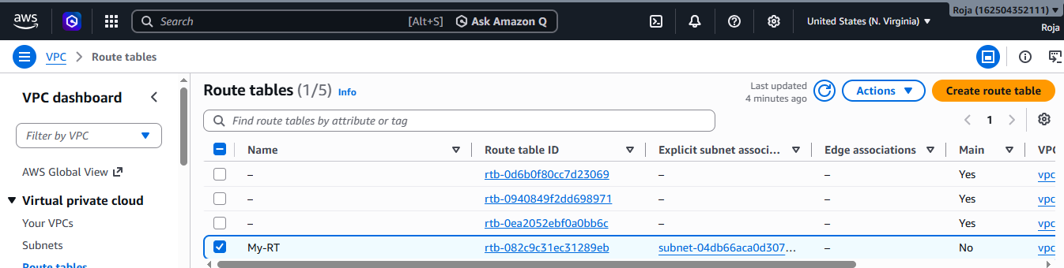

- Click the Routes tab at the bottom.
- Click on Edit routes and add Internet Gateway and click on save changes.

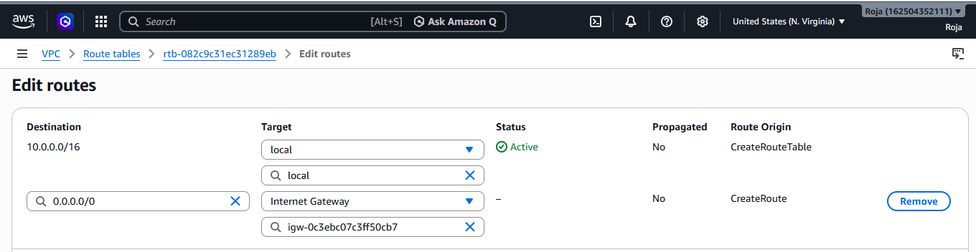
- Now verify in routes tab at the bottom.
- You should see both local and internet routes
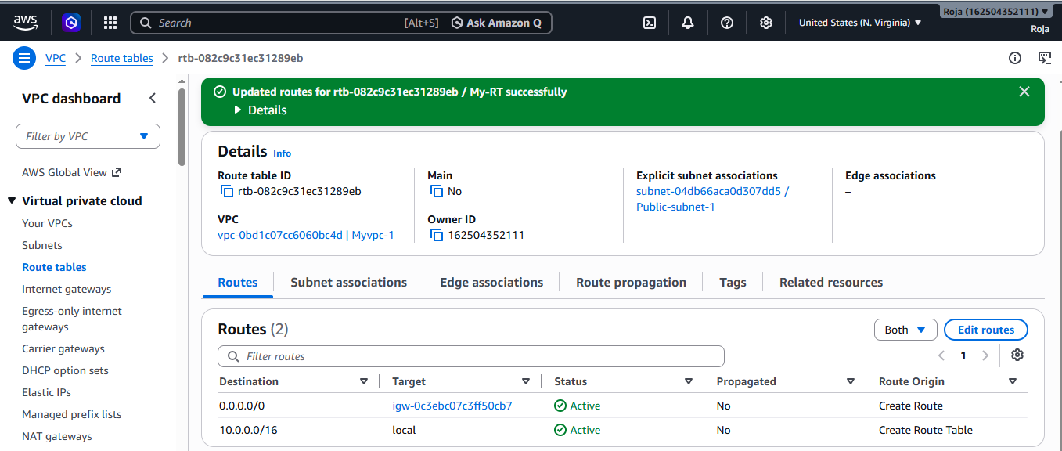

7. Create EC2 in public subnet with t2.micro and install PHP.

- Go to EC2.
- Click Launch instance and name it Public-web-server
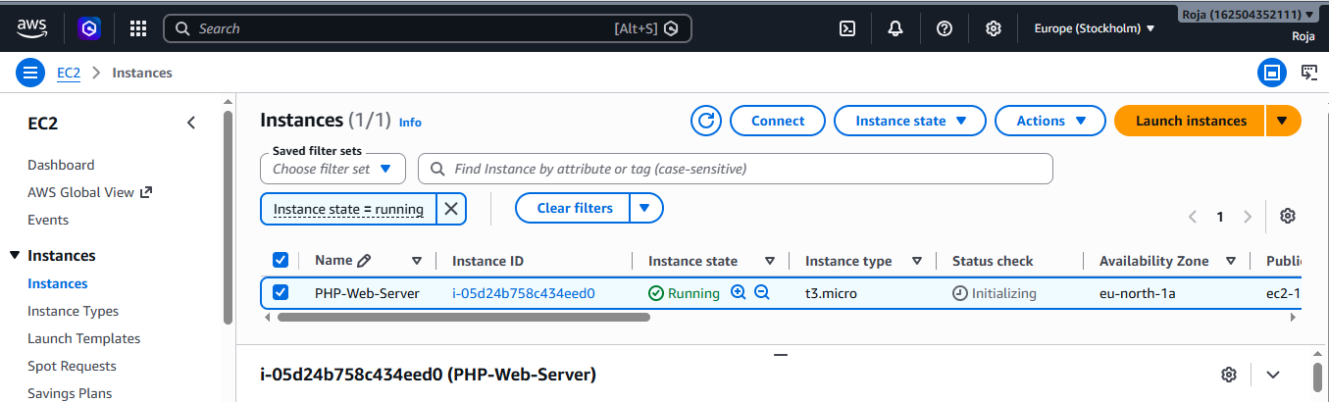

- Connect to EC2 using pem-key.pem ec-user@Ip address
- Update packages suing sudo yum update -y

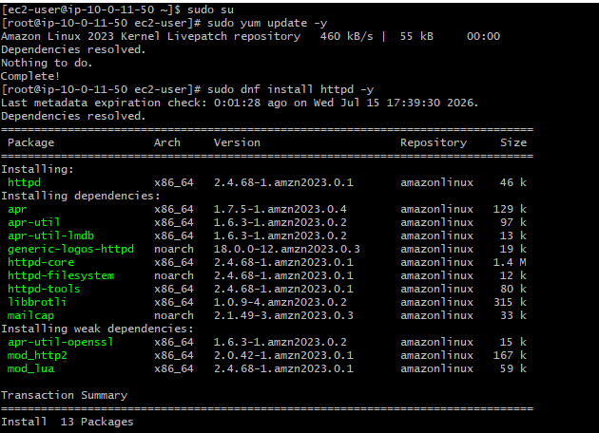

- Install Apache using sudo yum install httpd –y
- Then start and enable Apache
- Install PHP using sudo yum install php php-cli php-common -y
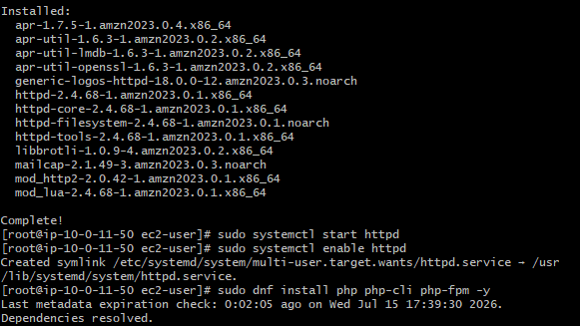

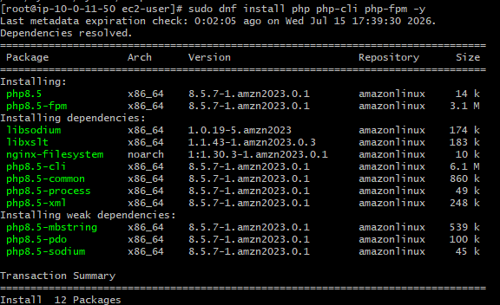

- Installed PHP successfully and restarted Apache.
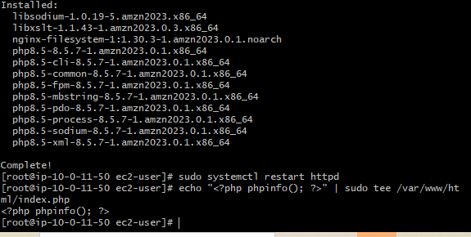
- Access PHP Page suing http://<EC2-Public-IP>/index.php

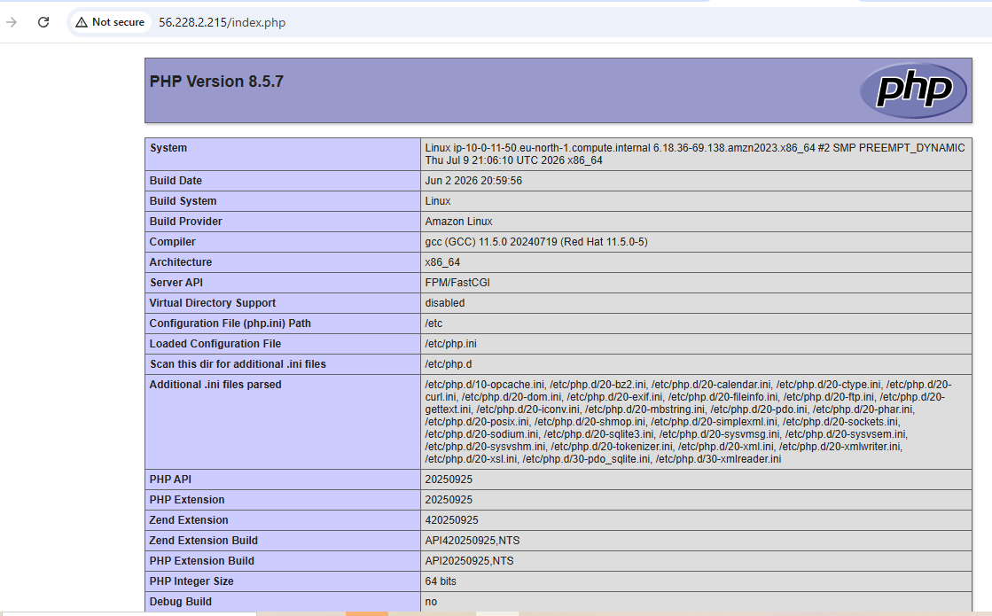

8. Configure NAT gateway in public subnet and connect to private instance.
- Created a NAT gateway, public subnet and private instance
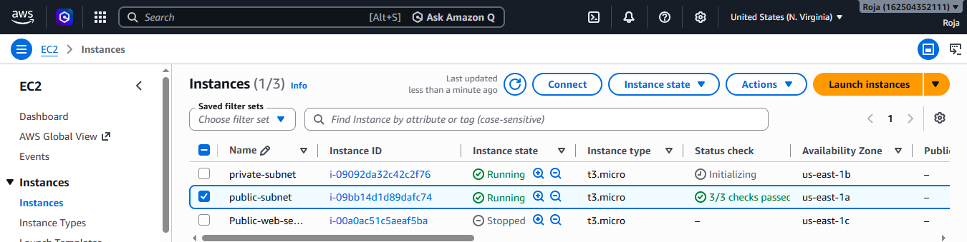
- Connect to Bastion Host.
- Connect to SSH from the Bastion Host to the Private EC2

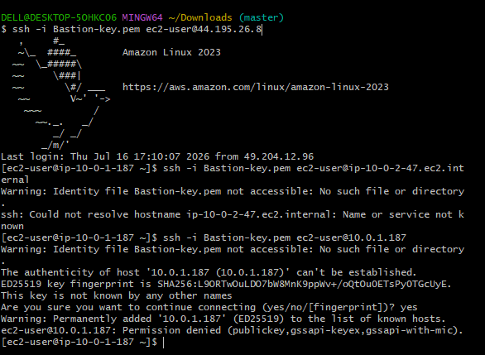

9. Install Apache Tomcat in private EC2 and deploy a sample app.
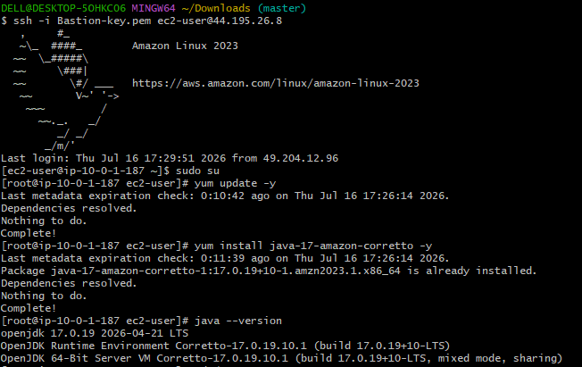

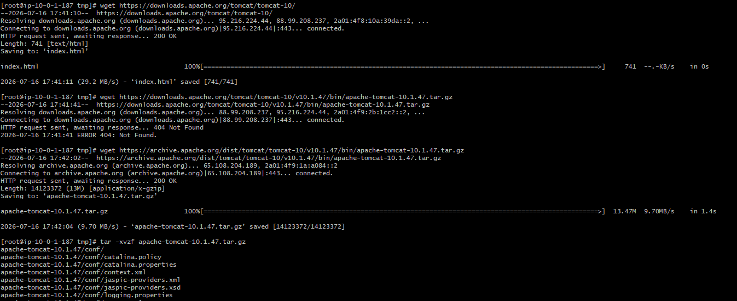

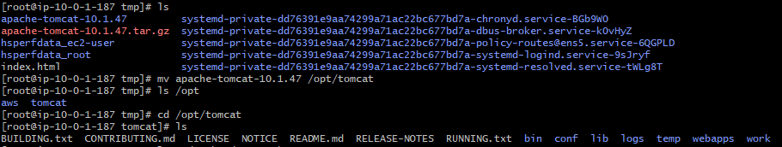

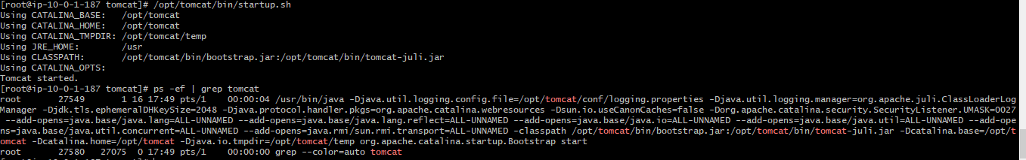

10. Configure VPC flow logs and store the logs in S3 and CloudWatch.
Created S3 Bucket
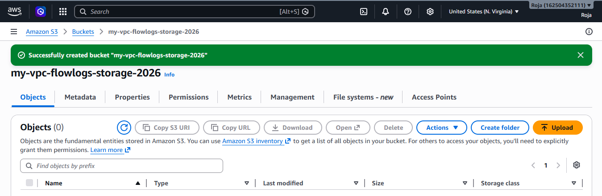
Created Cloud watch log

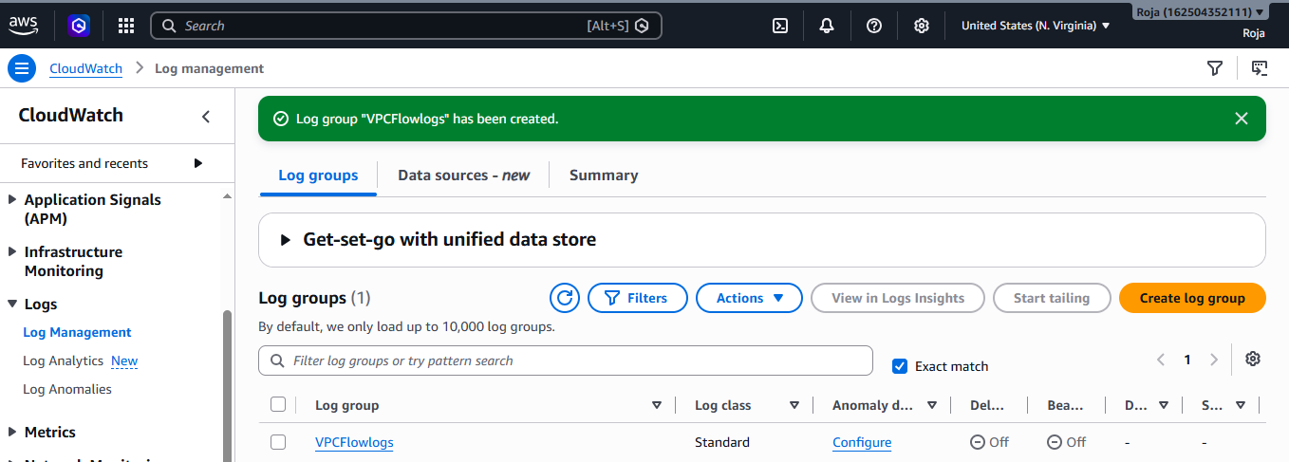

Vpc flow log created

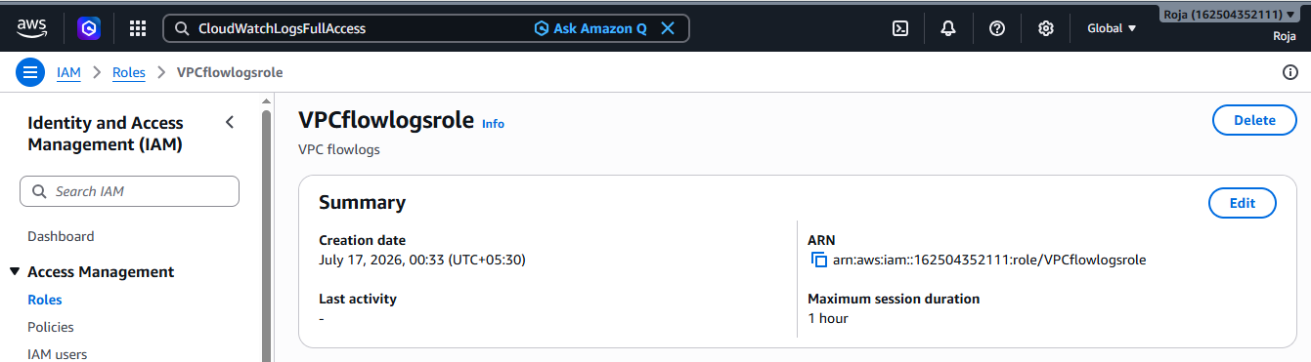

Trust policy updated

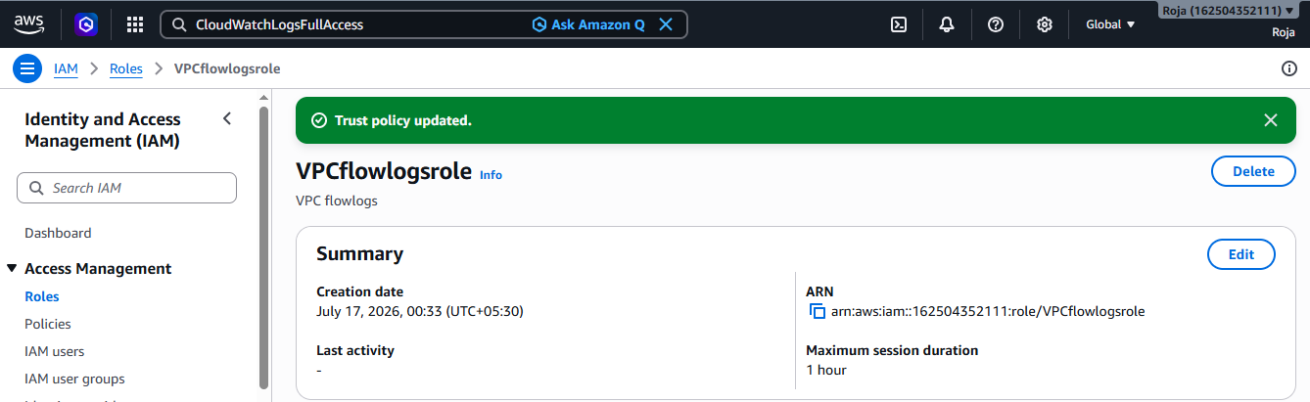

Configure VPC Flowlogs to cloudwatch and now the logs are sent to cloudwatch logs
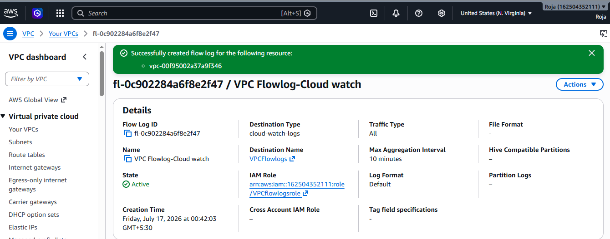

Configure VPC Flow Logs to S3 and Flow logs are now stored in Amazon S3

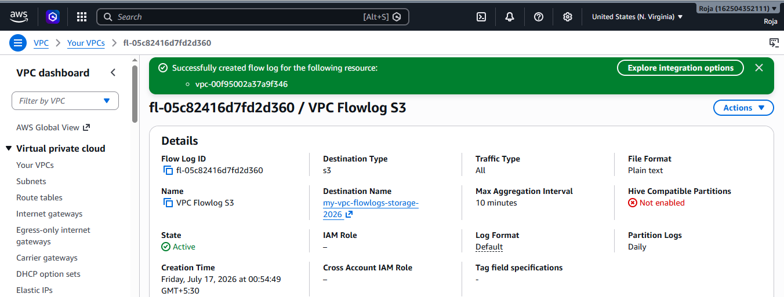

Verify Flow logs in VPC:

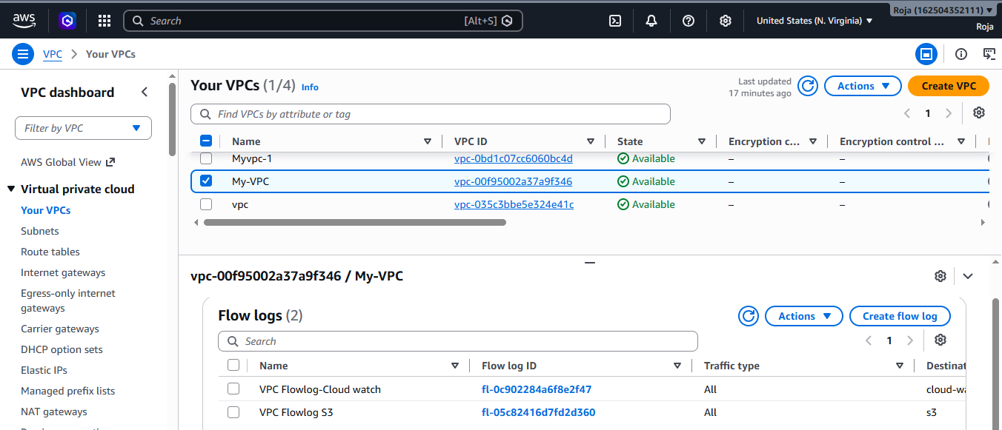

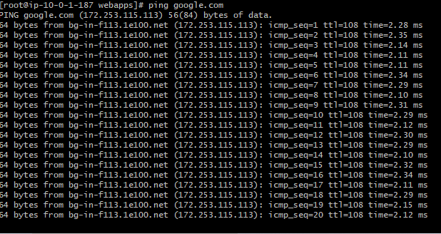

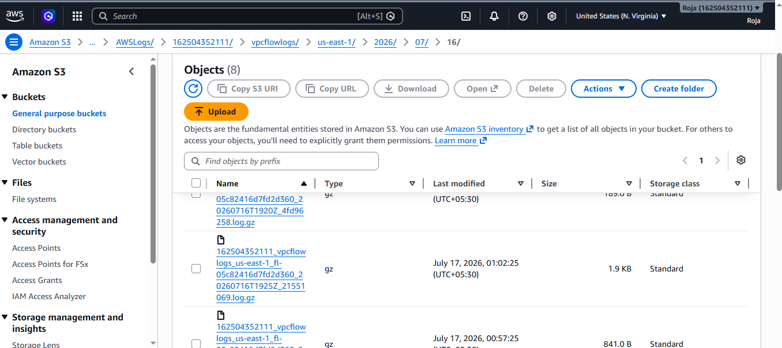

Viewed the logfile:

